- Create user with name Techie and provide sudo access to user.
sudo useradd -m Techie
sudo passwd Techie
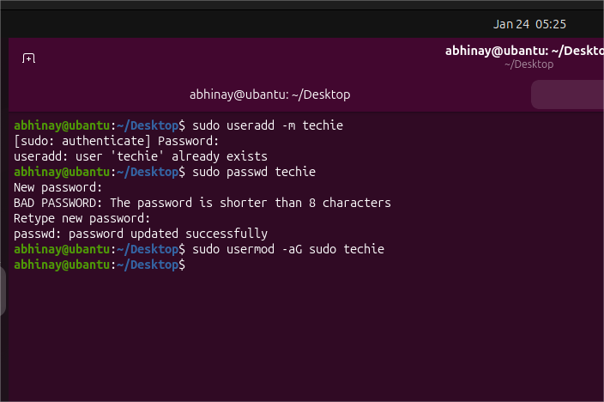
- Navigate to the home directory.
cd ~
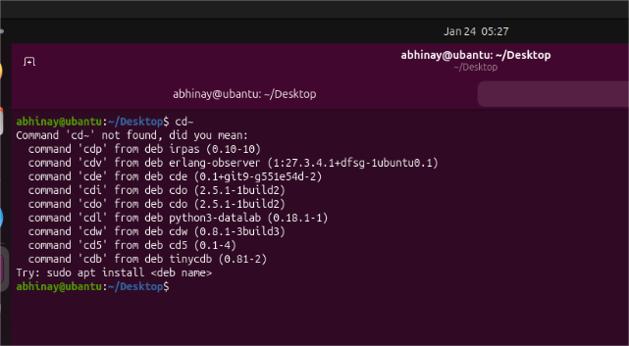
- Create a new directory.
mkdir mydir
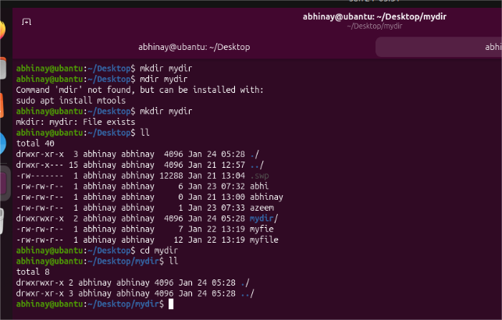
- List the contents of a directory.
Ll
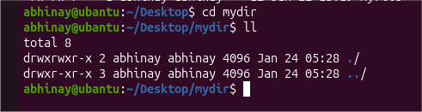

- Change the current directory.
cd mydir
- Create a new empty file.
touch file.txt
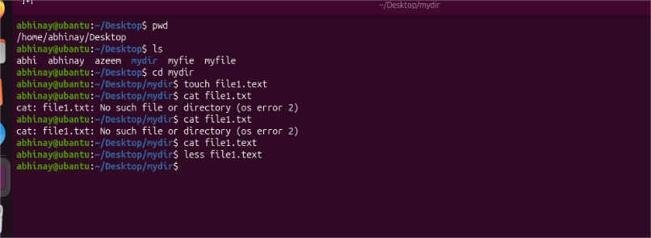
- View the contents of a file.
cat file.txt
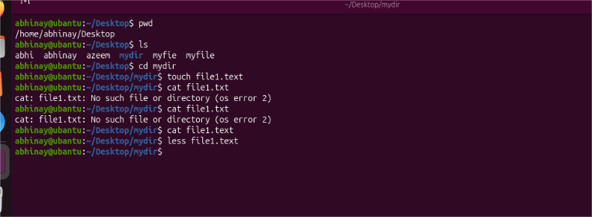
- Copy a file to another location.
cp filename file location
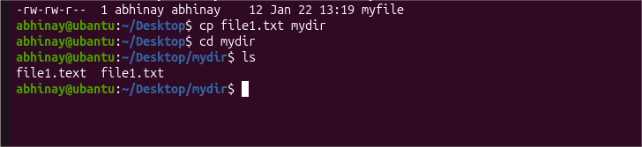
- Move a file to another location.
Mv oldfile newfile
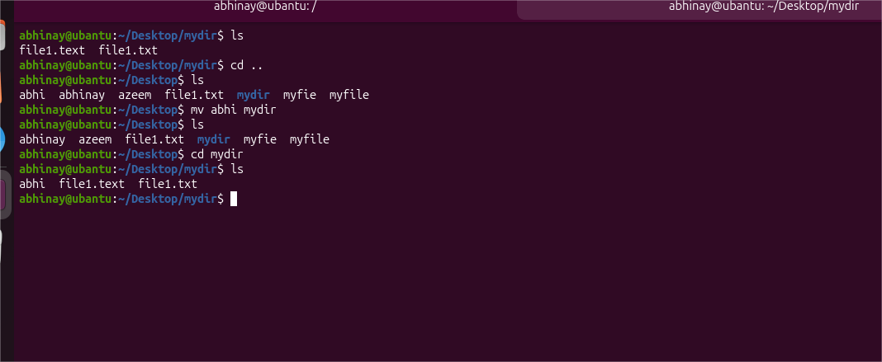
- Rename a file.
mv oldname.txt newname.txt
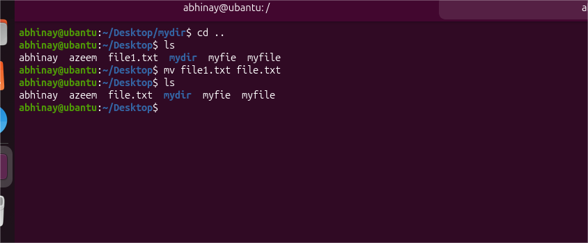
- Delete a file.
rm file.txt
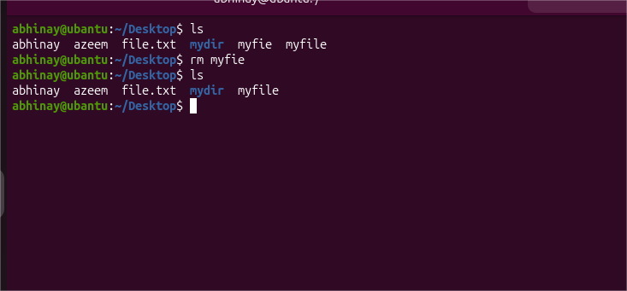
- Grant or revoke permissions on a file or directory.
chmod 755 filename
chmod u+x filename
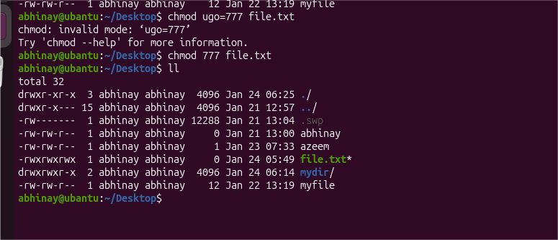
- View the current date and time.
Date
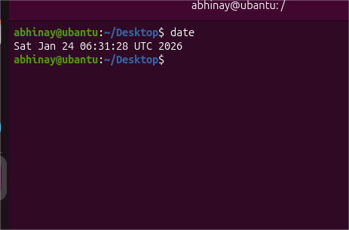
- Check the system uptime.
Uptime
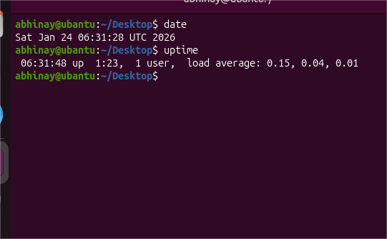
- View the running processes.
ps -ef
top
htop
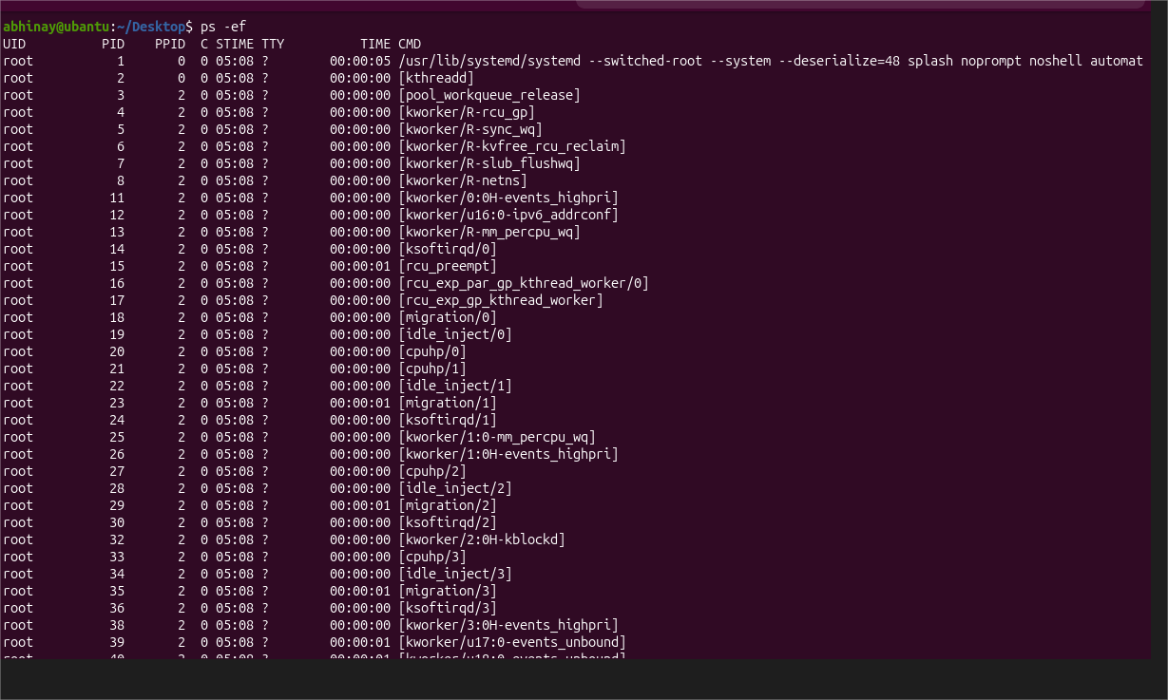
- Kill a running process.
kill PID
kill -9 PID
pkill process_name
- Install a package using the package manager (e.g., apt or yum).
sudo apt install nginx
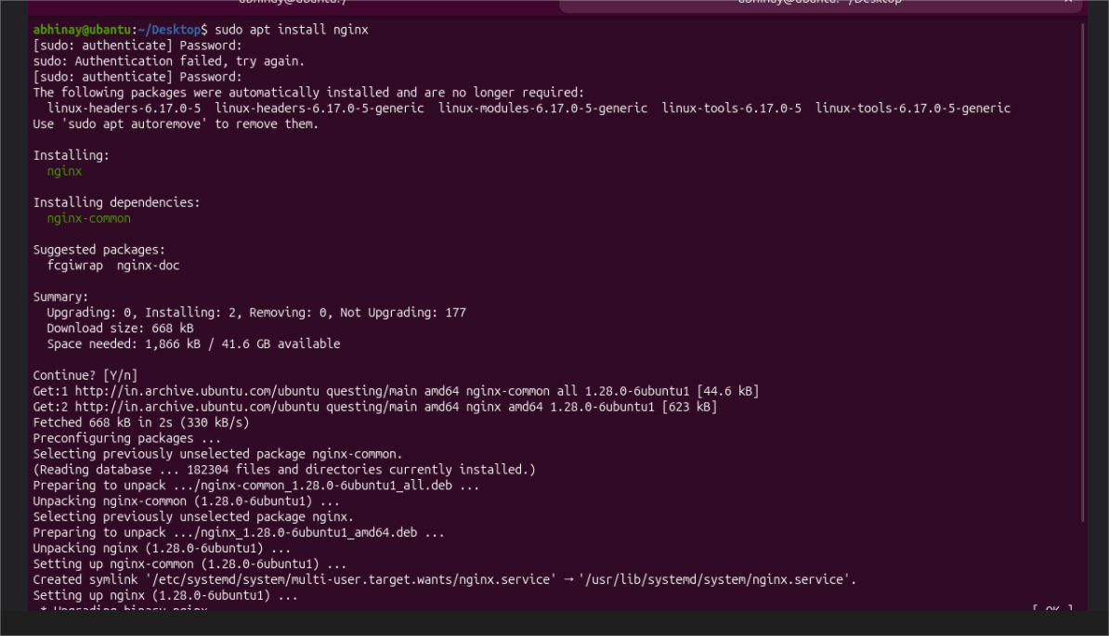

- Update the system packages.
sudo apt update && sudo apt upgrade -y
# or
sudo yum update -y

- Create a symbolic link.
ln -s /path/original file_link
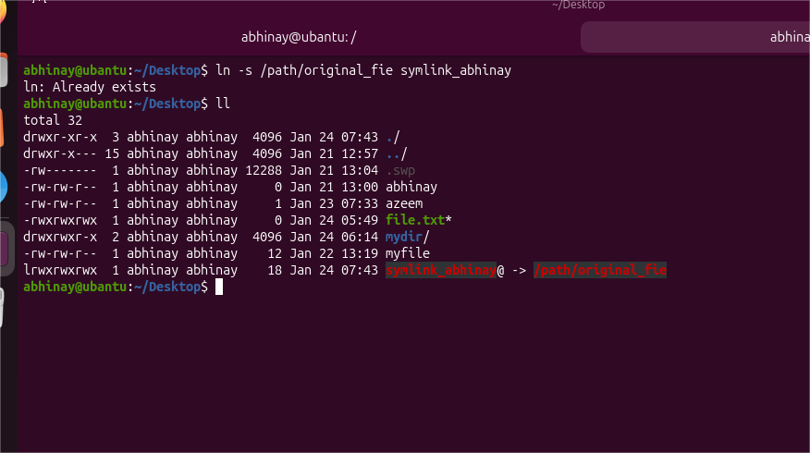
- Search for files using the find command.
find / -name file.txt
find /var -type f -size +10M
- Compress and decompress files using tar.
tar -cvf archive.tar mydir/
tar -xvf archive.tar
tar -czvf archive.tar.gz mydir/
tar -xzvf archive.tar.gz
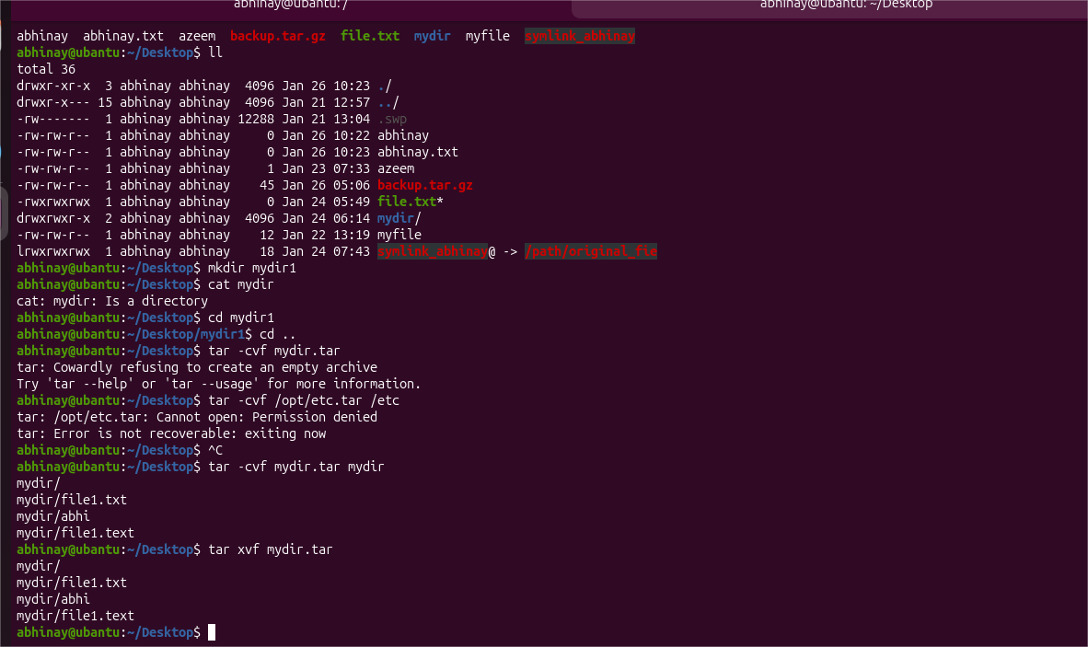

- Monitor system resources with top or htop.
Top , free -m
df -h , htop
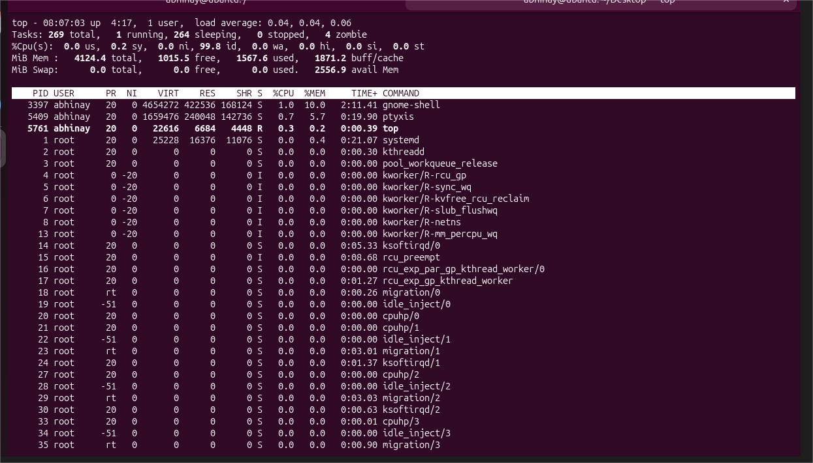

- Create and manage user groups.
sudo groupadd devops
sudo usermod -aG devops Techie
groups Techie
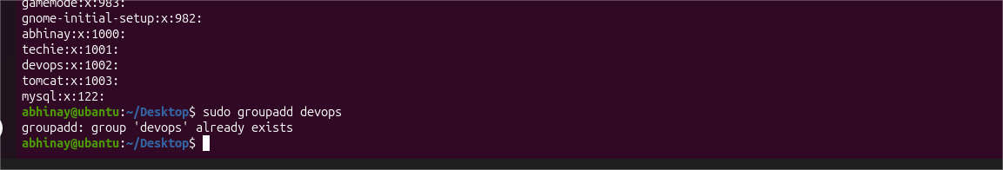
- Set up SSH password less authentication.
ssh-keygen
ssh-copy-id user@server_ip
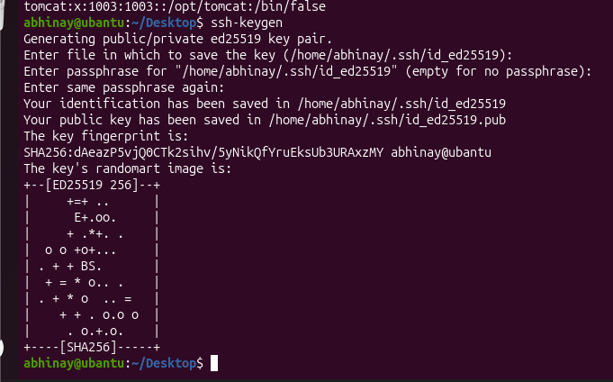
- Monitor log files using tail or grep.
tail -f /var/log/syslog
grep "error" /var/log/syslog
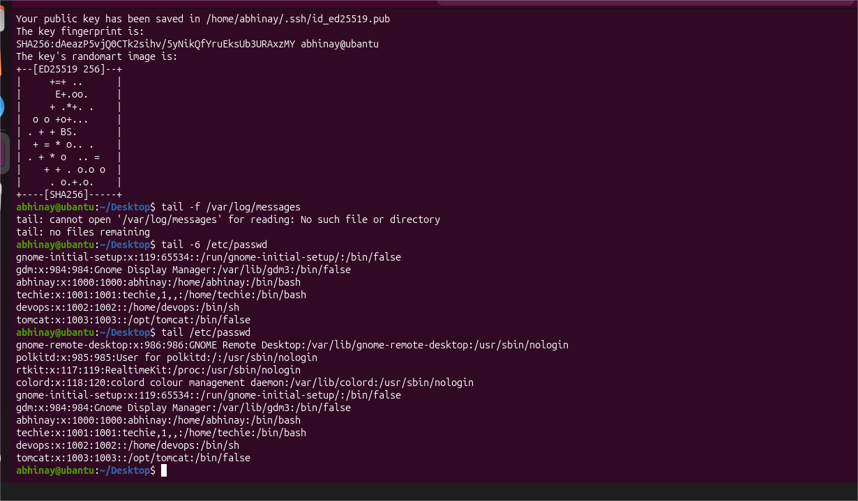
- Set up a web server (e.g., Apache or Nginx).
sudo apt install apache2
sudo systemctl start apache2
sudo systemctl enable apache2
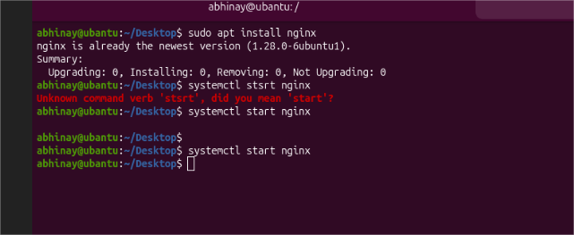

- Configure and secure a MySQL Database.
sudo apt install mysql-server
sudo mysql_secure_installation
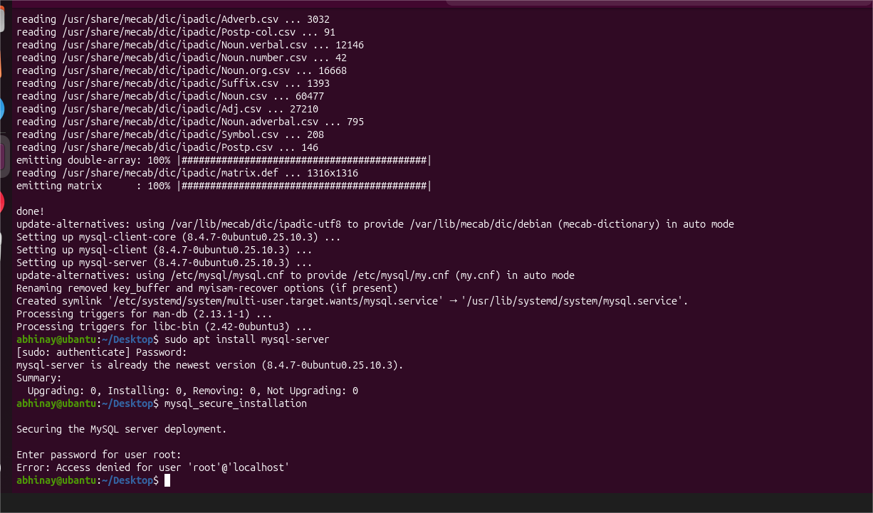
- Set up a Application Server (e.g.,Apache Tomcat)
sudo apt install default-jdk -y
tar -xvf apache-tomcat.tar.gz
mv apache-tomcat /opt/tomcat
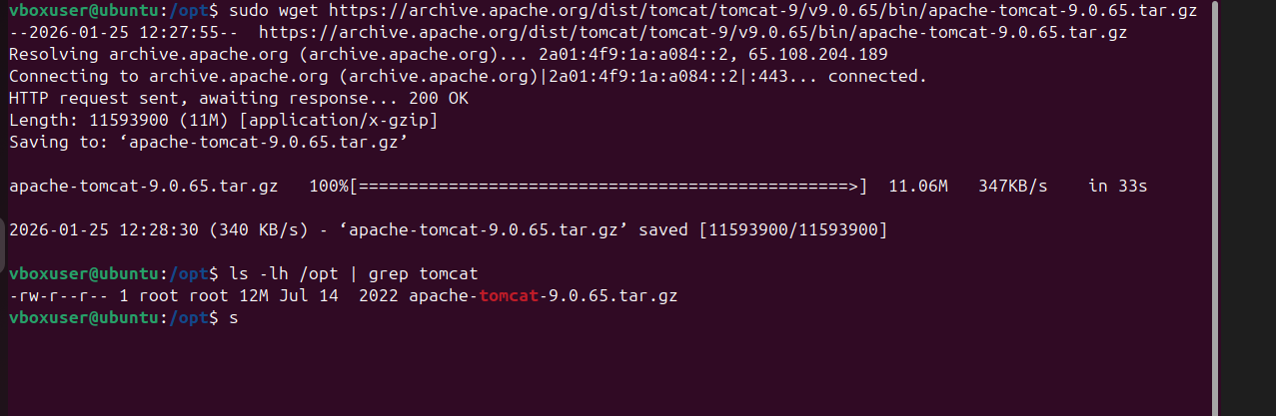

- create a service file for Apache Tomcat.(Should execute by using systemtctl command)
sudo nano /etc/systemd/system/tomcat.service
[Unit]
Description=Apache Tomcat

After=network.target

[Service]
Type=forking
User=tomcat
Group=tomcat
ExecStart=/opt/tomcat/bin/startup.sh
ExecStop=/opt/tomcat/bin/shutdown.sh
[Install]
WantedBy=multi-user.target

sudo systemctl daemon-reload
sudo systemctl start tomcat
sudo systemctl enable tomcat
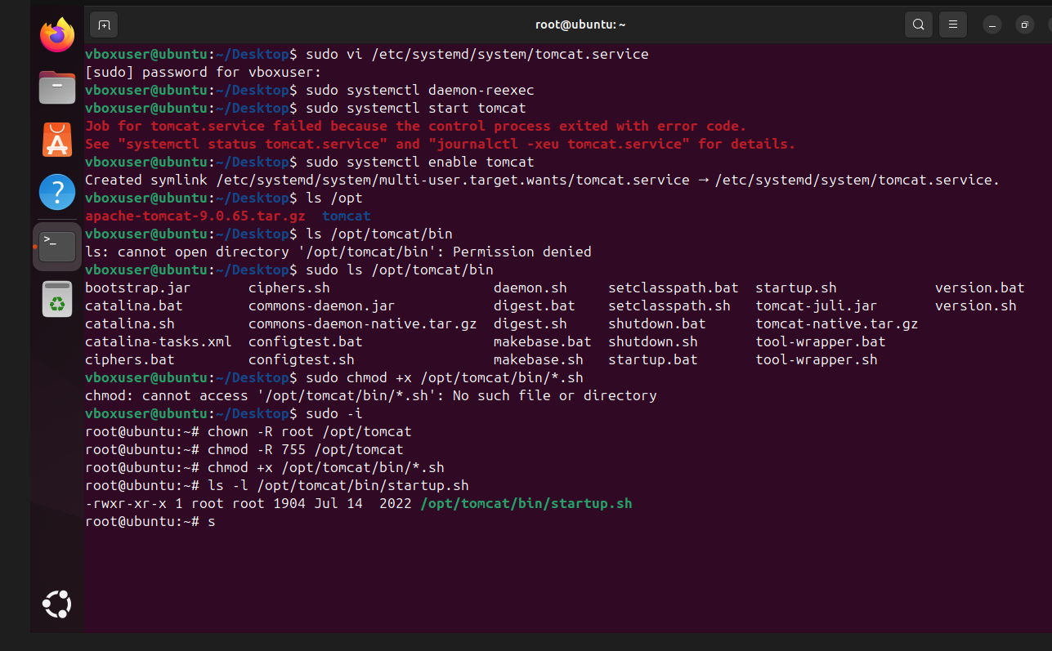

- Print specific columns from a delimited file.
awk -F',' '{print $1,$3}' file.csv
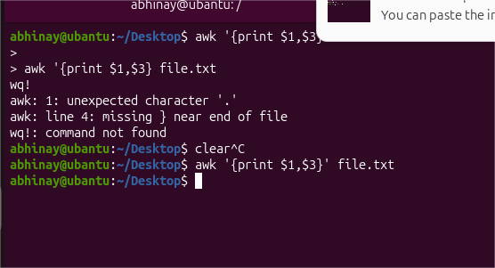
- Filter and print lines based on a specific pattern or condition.
grep "ERROR" logfile.txt
awk '$3 > 100' file.txt
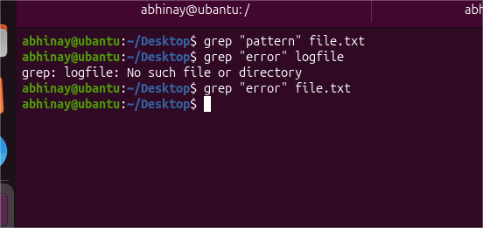
- Calculate and print the average, sum, or other statistics of a column.
awk '{sum+=$2} END {print sum, sum/NR}' file.txt
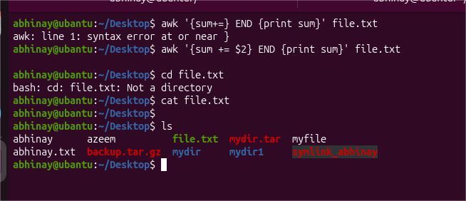

- Perform string manipulation, such as extracting substrings or changing case.
awk '{print substr($1,1,4)}' file.txt
awk '{print toupper($1)}' file.txt
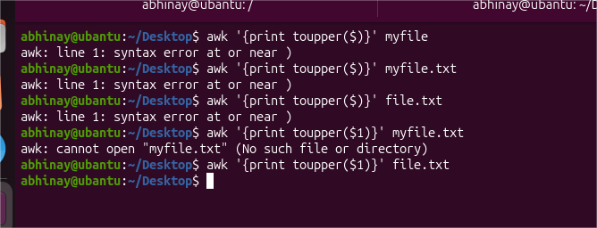
- Count the occurrences of a specific pattern in a file.
grep -o "fail" file.txt | wc -l
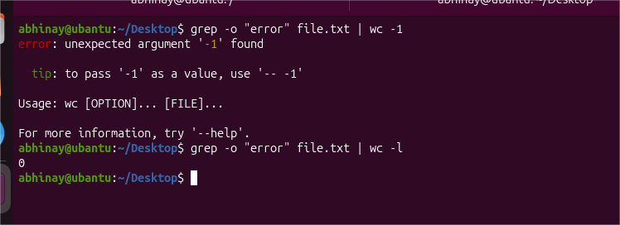

- Sort lines based on a specific field or column.
sort -k2 -n file.txt
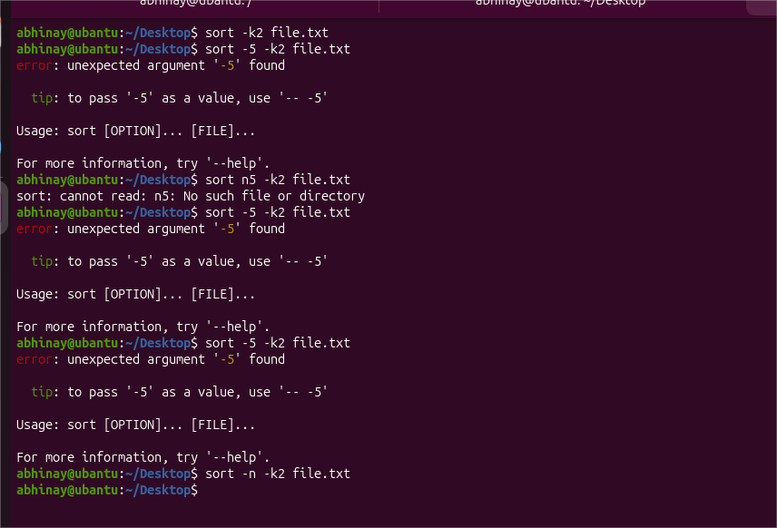
- Merge multiple files based on a common field or column.
join file1.txt file2.txt
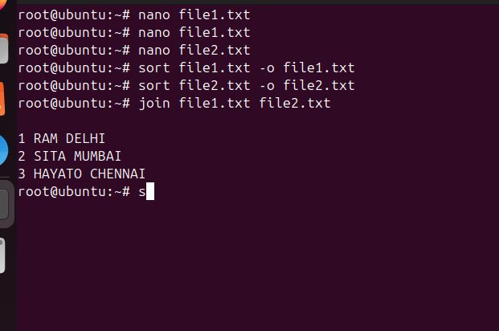
- Substitute text in a file using search and replace.
sed 's/old/new/g' file.txt

- Delete specific lines based on a pattern or line number.
sed '5d' file.txt
sed '/error/d' file.txt
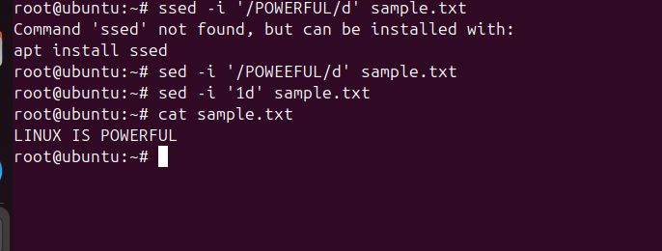

- Append or insert text before or after a specific pattern or line.
Command: sed '2a New Line' file.txt
Explanation: Adds ("appends") a new line of text right after line number 2

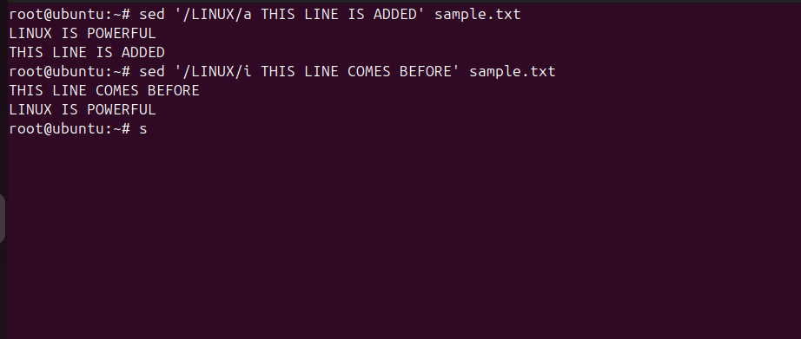
- Print only specific lines from a file.
Command: sed -n '3,5p' file.txt
Explanation: Tells the computer: "Only show (print) lines 3, 4, and 5."
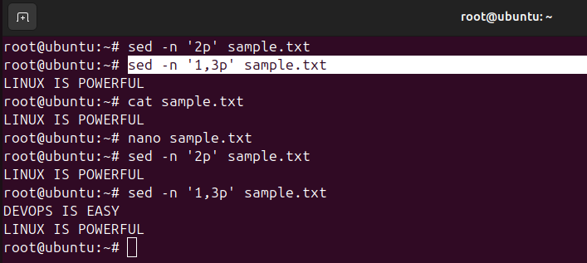

- Copy file from linux to windows machine

- 5 use cases for AWK and 5 use cases for sed

5 use cases of AWK
Column extraction
Log analysis
Data aggregation
Filtering records
Report generation
5 use cases of SED
Search & replace
Delete lines
Insert text
Modify configs
Batch file edits

